For Auto Gear Head

Apde Client chelle aa links mokli ti

Home Page

https://revenuewala.com/AutoGearHead/Final/

About Page

https://revenuewala.com/AutoGearHead/Final/about.html

Contact Us

https://revenuewala.com/AutoGearHead/Final/contact.html

Login

https://revenuewala.com/AutoGearHead/Final/login.html

Cart

https://revenuewala.com/AutoGearHead/Final/cart.html

Link Change

Brands

https://revenuewala.com/AutoGearHead/Final/brands.html

checkout

https://revenuewala.com/AutoGearHead/Final/checkout.html

Faq

https://revenuewala.com/AutoGearHead/Final/faq.html

Privacy

https://revenuewala.com/AutoGearHead/Final/Privacy.html

product-detail

https://revenuewala.com/AutoGearHead/Final/Product-detail.html

Register

https://revenuewala.com/AutoGearHead/Final/register.html

shop

https://revenuewala.com/AutoGearHead/Final/shop.html

Wishlist

https://revenuewala.com/AutoGearHead/Final/wishlist.html

now client last na changes

Home:

1. Footer: You can check the reference link. It has charcoal black background. use the exact shade.

https://eventflare.io/

2. Just above the Footer: (Change the font color from white)

(a) "KNOW IT ALL FIRST!

Never Miss Anything From Multikart By Signing Up To Our Newsletter."

Change it to:

"KNOW IT ALL FIRST!

Never miss any update from AutoGearheads."

(b) "Enter your email" change to "Enter your Contact Number"

(c) "Subscribe" change to "Submit"

-This will help in gathering data from customers.

3. Font color of "Never miss any update from AutoGearheads." to black (From white)

4. There is a 'P' icon beside the search bar. Remove it and add a search bar icon (Magnifying glass)

5. Header - Inside the search box - remove All categories.

6. Header - Search box - show auto recommendations

7. Header - Change in the color combination around the Search box, and cart icon. (Reference attached)

About us:

1. This is not what we did last time. I will share a small a reference image.

Contact us:

1. At the right side of the page: Remove the text "Contact, Address, Address, Fax". Only keep the icons.

2. Header area, why is that icon or a symbol beside "Contact"? Remove it

Login:

1. Instead of creating a page, we can also have a pop-up window? (Reference added)

Cart:

1. What is the 'Action column designed for"

2. Add rupee symbol where ever amount is mentioned, and commas must be according to indian currency system.

Listing Page:

1. Not built according to the reference provided.

Create Account:

1. Why is there a 2 separate pages for create account and login. it should be integrated in to one page only. Nevertheless, we are looking for a pop-up option only.

General:

No consistency in the search bar template & mobile Responsive issue

1.

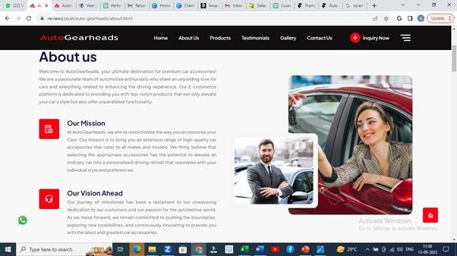

Apde juni banavi ti emni j website ema thi about us same content and section levanu current website mate

2.

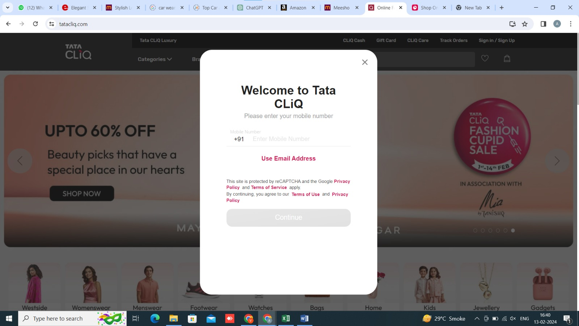

Pop-up Reference for login or create a new account.

3.

Listing page:

1. https://elegantautoretail.com/products/snug-memory-foam-neck-rest-xl-car-cushion-pillow-black?variant=44243032015072

Look how the left half of the page remains static, and we do not have to scroll to view the entire images.

2. https://www.meesho.com/stylish-leather-watches-for-men-combo/p/2j7z8

Combination of both the references to create right side of the page.

I have combined and created a template for you.

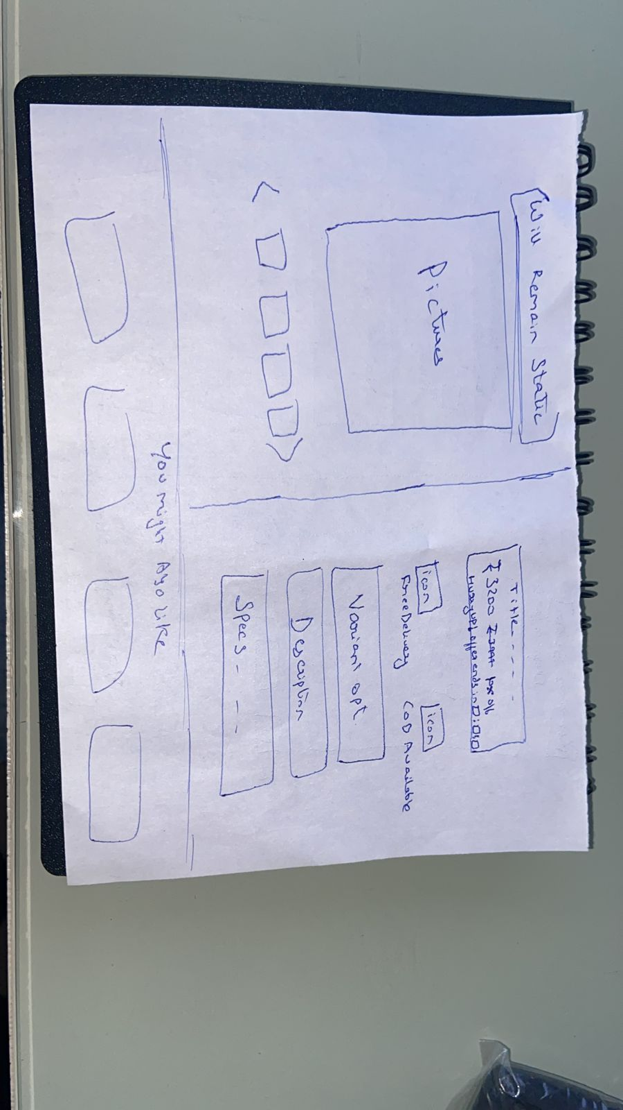

Header color combination reference (around the search bar icon it is shown red, but we have to make it grey only)

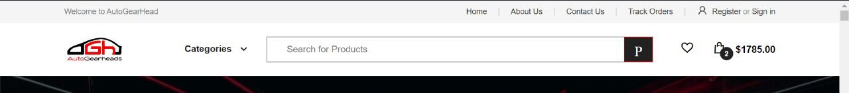

Give a wishlist option as well (beside add to cart)

